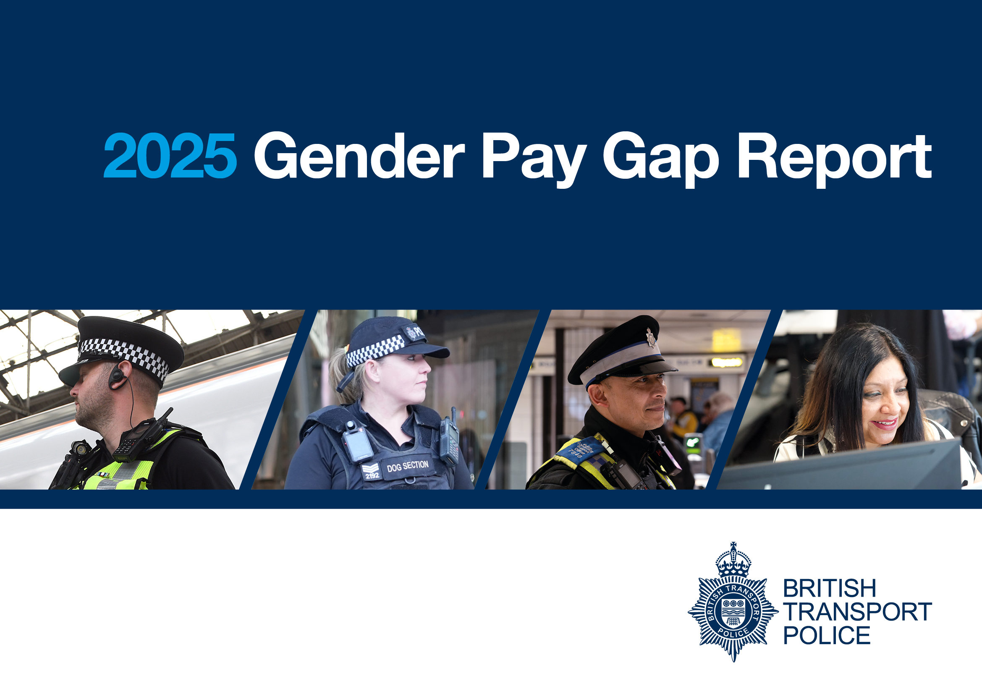
Foreword
“Driving our commitment to understanding and addressing the underlying causes of gender pay disparity is a commitment of mine, and for the eighth consecutive year, I am pleased to report that we’re still making progress in narrowing the gender pay gap.
Not only does this help us become a force that attracts, supports, and nurtures talent irrespective of gender but it also helps us build a workplace where everyone can thrive.
There are some reassuring statistics in this years’ report, but it does show that the gap still persists in some areas which we will continue working hard to address. If we truly want to be a world leading force, we must continue to pursue initiatives designed to attract and retain skills and talent from diverse backgrounds.
Reducing pay differences between genders remains a priority as we strive to create an environment where women are not only drawn to our organisation but are also supported and able to flourish.
Gender pay gap reporting plays a vital role in holding us accountable to this ambition, and we welcome the transparency and scrutiny it brings.”

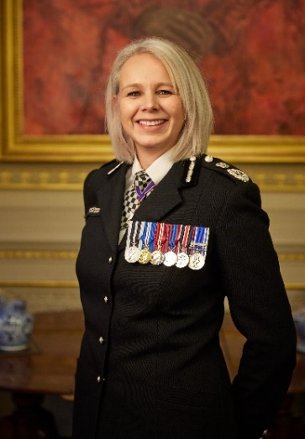
Lucy D’Orsi CVO QPM
Chief Constable
Why are we reporting on our gender pay gap?

At British Transport Police, we are committed to building a modern and inclusive force where our people reflect the best of our communities. In 2025 the British Transport Police employed approximately 4,953 police officers and staff. ​This is our eighth report for the period 1 April 2024 to 31 March 2025, the data used for this report is taken at the snapshot date of 31 March 2025.

What does the data look like?

Table 1 - Gender split for all employees over the last five years
Gender | 2025 staff and officer’s total workforce | 2024 staff and officer’s total workforce | 2023 staff and officer’s total workforce | 2022 staff and officer’s total workforce | 2021 staff and officer’s total workforce
Male | 65.4% | 66.2% | 67.42% | 68.22% | 68.7%
Female | 34.6% | 33.8% | 32.58% | 31.78% | 31.3%

Within this, the gender spilt of our officers and staff for the past five years is:

Overall Workforce Split
Table 2
Gender Split of overall Headcount | 2025# |  | 2024 |  | 2023 |  | 2022 |  | 2021
Gender | Officers | Staff | Officers | Staff | Officers | Staff | Officers | Staff | Officers | Staff
Male | 47.4% | 18.0% | 48.8% | 17.4% | 50.7% | 16.7% | 54.7% | 13.5% | 50.9% | 17.8%
Female | 14.3% | 20.3% | 14.4% | 19.4% | 14.2% | 18.4% | 15.7% | 16.1% | 13.7% | 17.5%
Total | 61.7% | 38.3% | 63.2% | 36.8% | 64.9% | 35.1% | 70.4% | 29.6% | 64.6% | 35.4%

While the overall gender split remains broadly consistent with previous years, this reporting year marks the first time women represent over a third of the workforce, following a 0.8% increase in representation.
Staff Gender Split
Table 3
Gender | 2025 | 2024 | 2023 | 2022 |  | 2021
Male | 47% | 47.3% | 47.6% | 45.6% |  | 50.3%
Female | 53% | 52.7% | 52.4% | 54.4% |  | 49.7%
In 2025 the gender split amongst the staff group remains in favour of females, with a marginal increase on last year of 0.3%, the staff group continues to have the highest proportion of female employees. Civil Service Statistics report similar gender split at 54.6%, up slightly from 54.5% in 2024.
Officer Gender Split
Table 4
Gender | 2025 | 2024 | 2023 | 2022 |  | 2021
Male | 76.8% | 77.2% | 78.2% | 77.8% |  | 78.8%
Female | 23.2% | 22.8% | 21.8% | 22.2% |  | 21.2%
The gender split amongst the officer group has remained consistent over the last 4 years. For officers, the data shows a slight increase in the proportion of female officers by 0.4% to 23.2%. This shows an overall increase in the last 2 years of 1.4%, the highest representation in several years. Despite this increase, we continue to have the lowest female officer representation in comparison to Home Office police forces who have reported an average increase in female officers of 0.7% to 36.1%.
Mean and Median Gender Pay Gap
- 2025 mean (average) pay gap in hourly pay is 2.28%. This represents a reduction from 2024 (2.34%).
- 2025 median pay gap in hourly pay is 2.70% (the difference between the mid points in the range of hourly pay). This represents a reduction from 2024 (3.58%)

All Employees Male-Female Gap
Table 5
Averages | All employees hourly rate mean and median
Averages | 2025 |  |  |  | 2024
Averages | Male | Female | Gap | Percentage | Male | Female | Gap | Percentage
Mean (average) hourly rate | £21.94 | £21.44 | £0.50 | 2.28% | £20.54 | £20.06 | £0.48 | 2.34%
Median hourly rate | £21.11 | £20.54 | £0.57 | 2.70% | £19.86 | £19.15 | £0.71 | 3.58%

BTP’s median pay gap compares well to the national median average published by ASHE UK on 1 November 2025. ASHE only reports the median pay gap and reported the gender pay gap among full-time employees as 6.9% in April 2025, down from 7.1% in April 2024. ASHE is based on a 1% sample of employee jobs taken from HM Revenue and Customs’ (HMRC’s) Pay As You Earn (PAYE) records. Population sample is approximately 300,000.

Graph 1
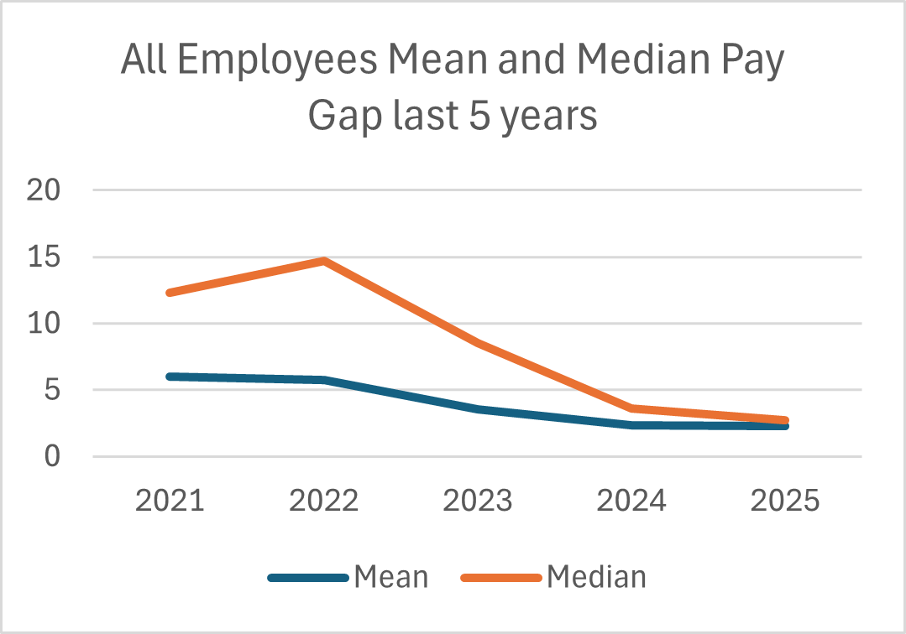
In 2025, both the mean and median gender pay gaps decreased, reflecting continued progress in closing pay disparity between male and female employees. Graph 1 illustrates changes over the past five years, showing a steady decline in the mean pay gap and a further reduction in the median gap compared to 2024.

Officers Male-Female Gap

Table 6
Officers Hourly Rates - Mean and Median
Averages | 2025 |  |  |  | 2024
Averages | Male | Female | Gap | Percentage | Male | Female | Gap | Percentage
Mean (average) hourly rate | £21.99 | £21.70 | £0.29 | 1.32% | £20.56 | £20.33 | £0.23 | 1.12%
Median hourly rate | £21.69 | £21.20 | £0.49 | 2.26% | £20.29 | £19.86 | £0.43 | 2.12%

Graph 2
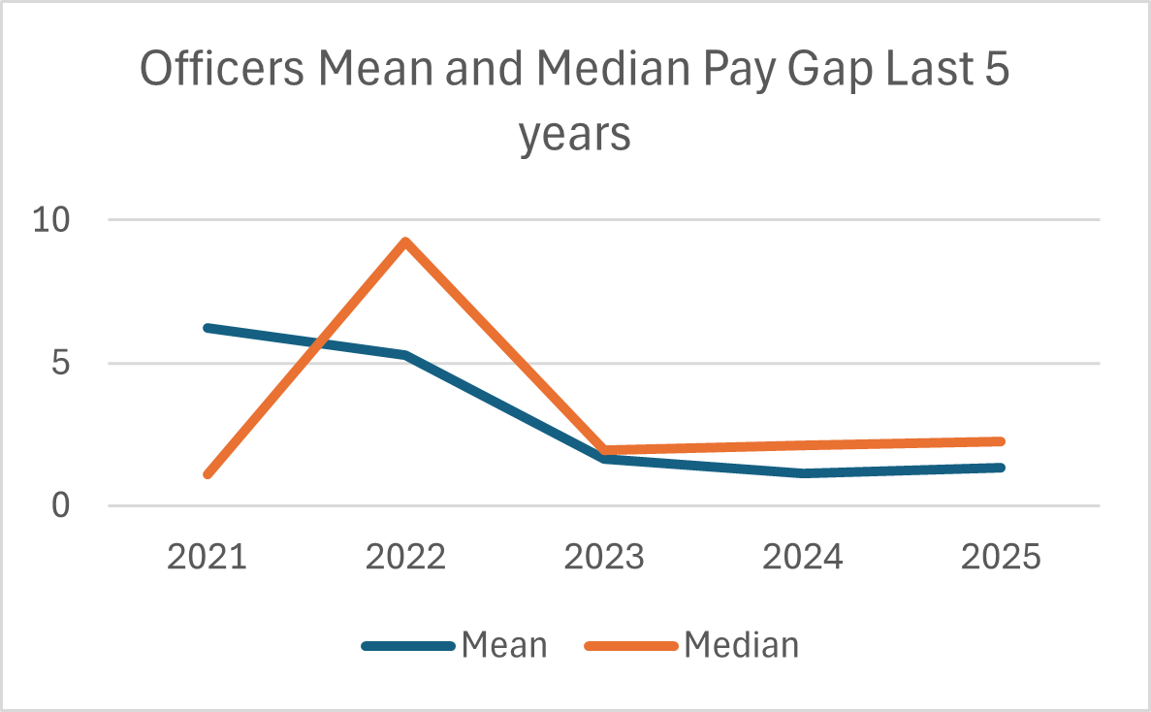
In 2025 the mean pay gap for officers increased from 1.12% to 1.32%. The median gap also increased this year from 2.12% to 2.26%. Graph 2 reflects the higher proportion of male officers in senior ranks and the departure of senior female officers during the period.

Staff Male-Female Gap
Table 7
Staff hourly rate mean and median
Averages | 2025 |  |  |  | 2024
Averages | Male | Female | Gap | Percentage | Male | Female | Gap | Percentage
Mean (average) hourly rate | £21.82 | £21.25 | £0.57 | 2.61% | £20.49 | £19.85 | £0.64 | 3.12%
Median hourly rate | £20.20 | £19.79 | £0.41 | 2.03% | £18.93 | £18.34 | £0.59 | 3.12%

Graph 3
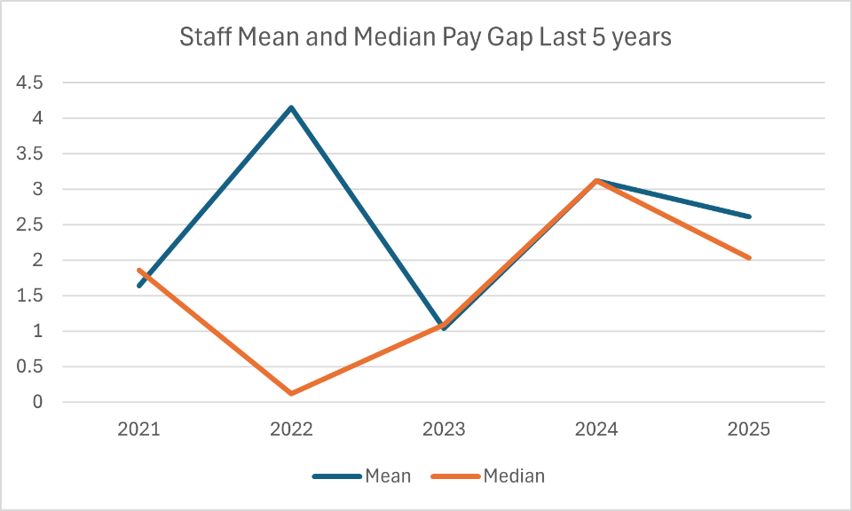
Graph 3 illustrates the reduction in both the mean and median gender pay gap for the staff group to 2.61% and 2.03% respectively. This reflects the increase seen in mean and median pay; minimum and maximum pay points also improved. More female staff were included this year (978 compared to 911 last year) one of the factors contributing to this is the growth in female representation.

Quartile Data

Quartiles are based on employees in receipt of a full pay on 31 March 2025
Table 8
All Employees – quartile pay bands
 | 2025 |  |  | 2024
Pay quartile | % Male | % Female | Hourly Pay range £ | % Male | % Female | Hourly Pay range £
Upper | 68.91% | 31.09% | 24.20 – 86.79 | 70.12% | 29.88% | £22.92 - £75.33
Upper Middle | 69.19% | 30.81% | 20.81 – 24.19 | 67.81% | 32.19% | £19.69 – 22.91
Lower Middle | 62.77% | 37.23% | 17.92 – 20.80 | 62.17% | 37.83% | £16.69 – £19.68
Lower | 62.44% | 37.56% | 10.95 – 17.91 | 63.30% | 36.70% | £9.83 - £16.68

The pay data is split into four quartiles to determine where the proportions of employees sit in the hierarchy. In 2025, the highest proportion of female employees remained concentrated in the lowest two pay quartiles, accounting for 74.79% overall, a slight increase from 74.53% the previous year. In contrast, female representation in the upper quartiles was 61.9%, reflecting a marginal decrease of 0.8%. This shift indicates that while progress has been made in some areas, overall, female employees continue to be disproportionately represented in lower paid roles.

Table 9

Officers – quartile pay bands
 | 2025 |  |  | 2024
Pay quartile | % Male | % Female | Hourly Pay range £ | % Male | % Female | Hourly Pay range £
Upper | 79.81% | 20.19% | 24.20 – 86.79 | 79.82% | 20.18% | 23.18 -75.33
Upper Middle | 78.84% | 21.16% | 21.45 – 24.19 | 78.94% | 21.06% | 20.03 – 23.18
Lower Middle | 76.08% | 23.92% | 17.92 – 21.44 | 76.72% | 23.28% | 16.69 – 20.02
Lower | 74.32% | 25.68% | 11.17 -17.91 | 75.94% | 24.06% | 10.26 -16.68

In 2025, the overall proportion of female officers in the upper quartiles remained unchanged. However, there was a slight increase in the lower two quartiles: the lower middle quartile rose by 0.64% (from 23.42%), and the lowest quartile increased by 1.62% (from 23.62%).
In 2025, 77.4% (24) of senior officer roles at Superintendent level and above were held by male officers, a slight increase from 76.2% in 2024. There are currently seven female officers ranked at Superintendent or above. During 2024–2025, senior female officers left the organisation which impacted on female representation at the higher ranks.

Table 10

Staff – quartile pay bands
 | 2025 |  |  | 2024
Pay quartile | % Male | % Female | Hourly Pay range £ | % Male | % Female | Hourly Pay range £
Upper | 50.11% | 49.89% | 23.32 – 76.77 | 51.61% | 48.39% | 22.14 – 91.00
Upper Middle | 46.72% | 53.28% | 20.06 – 23.31 | 47.44% | 52.56% | 21.34 – 22.14
Lower Middle | 44.18% | 55.82% | 17.23 – 20.05 | 47.36% | 52.64% | 15.46 – 21.34
Lower | 46.75% | 53.25% | 10.95 – 17.22 | 44.10% | 55.90% | 12.55 – 15.46

This year, female staff in the upper quartiles increased by 2.2% with higher representation in both the upper and upper middle quartiles. The overall proportion of female staff in the lower quartiles remained broadly the same in 2025. (109.07% compared to 108.54%). Encouragingly, headcount data shows 50/50 representation of males and females at grades C001 to Director. This balance at senior levels has contributed to a reduction in the gender pay gap within the staff group this year.

Bonus payments
Police Regulations allow for bonus payments to be made to officers. BTP has pay parity with Home Office forces and applies the same payments through policy. Bonus payments are paid in the following circumstances:
- Make the Difference Awards - officers and staff are eligible for these awards which recognise outstanding work or contribution; payments range from £25 to £500.
- PDR rating 1 - staff are eligible for an award of £500 if they achieve a rating 1 in their annual performance development review.
- Temporary targeted payments (TVP) – officers in hard to fill and demanding roles may receive a payment of up to £3,000. At present, BTP only utilises this allowance for Firearms Instructors, due to a national shortage of qualified officers. individuals.
In 2025, 604 employees received a bonus, a decrease of 9.85% on last year (670); Chief Officers are not eligible to receive bonuses.

Table 11 Bonus Payments
All employees
 | 2025 |  |  |  | 2024
 | Male (307) | Female (297) | Gap in £ | % Gap | Male (385) | Female (285) | Gap in £ | % Gap
Mean | £507.25 | £361.78 | £145.47 | 28.68% | £389.35 | £389.04 | £0.31 | 0.08%
Median | £450.00 | £500.00 | -£50 | -10% | £500 | £500 | £0 | 0%
Officers
 | Male (117) | Female (22) |  |  | Male (214) | Female (60)
Mean | £807.05 | £501.14 | £305.91 | 37.90% | £410.28 | £410.83 | -£0.55 | -0.13%
Median | £500 | £275 | £225 | 45% | £500 | £500 | £0 | 0%
Staff
 | Male (190) | Female (275) |  |  | Male (171) | Female (225)
Mean | £322.63 | £350.64 | -£28.01 | -7.99% | £363.16 | £383.22 | -£20.06 | -5.52%
Median | £300 | £500 | -£200 | 40% | £500 | £500 | £0 | 0%

A review of the bonus data shows:

- Overall, the mean bonus gap for all employees has widened, while the median pay gap has reversed. The increase in the mean gap reflects higher TVP bonus payments received by male officers this year. Last year, the average bonus for male officers fell by £176.08, narrowing the gap between male and female officers. However, this year the gap has grown again, with the mean bonus for male officers exceeding that of female officers by £145.
- This year, the distribution of bonuses between male and female employees became more balanced, with 50.83% awarded to males (307 individuals) and 49.17% to females (297 individuals), compared to 57% to males and 43% to females last year.
- In terms of the category of bonuses awarded, 60% (366) were Make the Difference, 36% (217) PDR and 4% (21) TVP.
- Consistent with last year, the distribution of bonuses to staff increased, with 77% awarded to staff and 23% to officers, compared to the previous split of 59.1% for staff and 41.9% for officers. Both groups are eligible for Make the Difference Bonuses, and this year 68% of those payments were allocated to staff.
- For officers, as with last year, the highest proportion (84.17%) of bonuses went to males, marking an increase for males this year. Both the mean and median bonus payments were higher for male officers. 20 out of 21 TVP bonus payments were awarded to male officers; the highest TVP bonus of £6,450 was awarded to a male officer, compared to £4,200 to a sole female officer.
- Consistent with last year, more female staff received a bonus than males (59.14% compared to 40.86%) and females received a higher mean bonus payment (£350.64). The mean bonus payment for both male and female staff reduced this year, however the value of the highest bonus payment was awarded to a male (£725) compared to £500 to females. The proportion of bonuses awarded across each bonus category was consistent with overall distribution between male and female staff (60/40 in favour of females).

What does this tell us about BTP’s gender pay gap?
- In 2025, there is an improvement in the gender pay gap. The mean pay gap reduced to 2.28%; this demonstrates that for every £1 a male earns, a female earns 97.7pence (compared to 97.6 pence last year). The median pay gap reduced to 2.70%
- The mean and median pay gap is lower for officers than for staff.
- For officers, both the mean and median pay gap increased this year, reflecting a higher proportion of male officers in senior ranks.
- For staff, we have seen a reduction in both the mean and median pay gap this year, this reflects the increased proportion of female staff in the higher pay quartiles
- The overall position for female employees in the pay quartiles remains broadly the same as last year, with a slight decrease in the proportion of female employees in the higher quartiles and increase in the lower pay quartiles compared to males which can be attributed to fewer female officers in senior ranks this year compared to last year.

Actions and Successes to date
Since the last report, the strategy has been agreed and implemented with activities focused on developing representation with positive action. With the expectation that changes will progress and develop over the next 12 months, strategies to reduce the gender pay gap included:

- Ongoing work to improve inclusive recruitment practices by reducing bias in selection to ensure talent is identified and thrives. Promotion eligibility expanded to include those with mid PDR ratings, ensuring the widest possible pool of candidates. The Recruitment team works closely with other departments to monitor assessment outcomes and share any disproportionality with the Leadership Academy, enabling targeted support where needed. Unconscious Bias training remains a core component of all assessor training across the organisation. We were also among the first forces in the country to pilot a part-time intake, widening access to policing and achieving 70% female representation.
- Established a female representation group to focus on attraction and retention, addressing barriers that historically limit female officer representation
- Where possible, we continue to advertise significant numbers of police staff vacancies as location agnostic where possible.
- Staff associations observe promotion posting panel for transparency of decision making.
- Continued to train panel members in inclusive assessment techniques, as well as unconscious bias training; a mandatory requirement to support boards.
- Implemented workplace adjustment passports which act as a clear reference point for employee needs
- Selection panels for recruitment, promotion boards are diverse and representative.
- Annual promotion boards provide frequent access to promotion opportunities for females and other under-represented groups.
- The Youth Engagement Strategy gives PCSOs clear direction and more opportunities to engage with young people. PCSOs will lead youth engagement, supported by a new dashboard that uses crime and demographic data to target efforts.

Next Steps

We are committed to ensuring that BTP reflects the communities we serve. Increasing female representation is a key priority for building public trust and confidence. Currently, we have the lowest proportion of female officers across UK policing, and we recognise the need for significant improvement. To address this, we are focusing on targeted actions in the following areas:
- Continue to consider options of flexible working to all employees returning from maternity leave, where operationally possible, to both attract and retain skills and talent from all backgrounds. Continue to offer flexible working options to all employees returning from maternity leave, where operationally possible, to attract and retain skills and talent from all backgrounds.
- Establish a Female Representation Working Group, led by a Chief Inspector to consolidate initiatives aimed at increasing female officer representation. The group will monitor progress, align efforts across teams, and ensure collective accountability for achieving this objective. accountability for achieving this objective. this objective
- Work with our Staff Networks to understand issues encountered by female colleagues, look at them with an intersectional lens and collaborate on solutions across the business using initiatives such as HeForShe and WhiteRibbon to develop allyship.
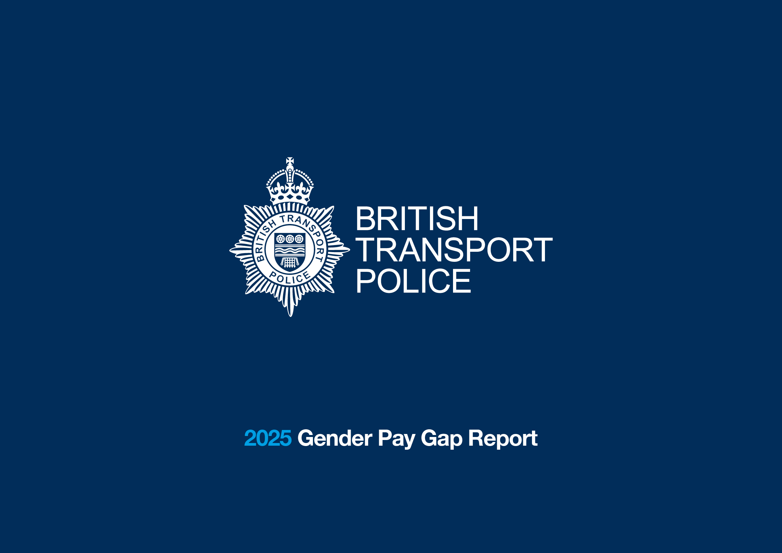
- Inclusion and Diversity business partnering will join the Policy and Reward team and will strengthen the overall approach to enhancing representation in line with our values and strategic objective ‘to build a modern and inclusive workforce where our people are well equipped, well led, well cared for and reflect the best of our communities’

Statistical bulletin - Civil Service Statistics: 2025 - GOV.UK
Gender pay gap in the UK - Office for National Statistics
Police workforce, England and Wales: 31 March 2025 (second edition) - GOV.UK

