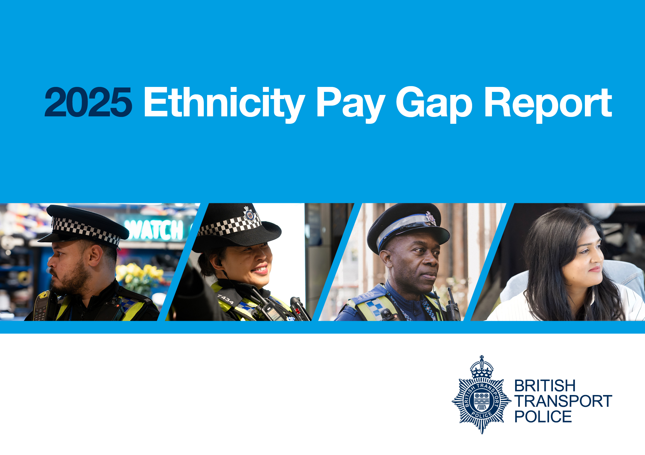

Foreword
“Continuing to increase the representation of ethnic minority officers and staff is absolutely vital to our ambition of becoming a world-leading police force. I’m pleased to report that for the fourth year of voluntarily publishing our ethnicity pay gap, we’ve seen a further overall reduction. However, I also recognise that behind these figures are real people and real experiences, and for many colleagues, pay gaps reflect broader issues around opportunity, progression, and belonging.
The report shows some encouraging signs that we’re beginning to close the mean pay gap, but it also makes clear that there’s still significant work to do. These gaps do not exist in isolation. They are closely linked to representation at senior levels, access to development opportunities, and the long-term impact of systemic barriers that exist across policing and wider society. Understanding and addressing those root causes is critical if we’re serious about lasting change.
In 2026, we’ll place a particular focus on bonus allocation, where disparities remain a key challenge. We’ll also continue to strengthen our recruitment campaigns, leadership development pathways, and our organisational capability to create an environment where fairness, inclusion and opportunity are built into everyday practice.
My ambition is for BTP to be a force that genuinely attracts, supports and nurtures talent irrespective of ethnicity, and where everyone feels valued and able to thrive. Ethnicity pay gap reporting is an important part of that journey, not just as a measure of progress, but as a tool to inform action, build trust, and hold us accountable for the culture we’re creating.”
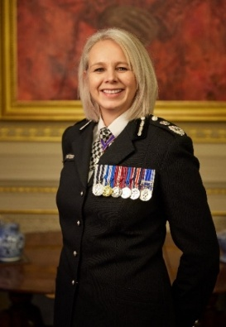
Lucy D’Orsi CVO QPM
Chief Constable

Why are we reporting on our ethnicity pay gap?
At British Transport Police, we remain committed to building a modern, inclusive, and representative force that reflects the communities we serve.
Although there is still no legal requirement to conduct or publish ethnicity pay gap analysis, we continue to uphold our pledge under the Race Action Plan to review and share our data transparently. This commitment ensures accountability and drives meaningful action to address disparities and promote equity across our organisation. This is our fourth ethnicity pay gap report.

In the absence of a mandatory framework for ethnicity pay gap reporting, we have replicated the measures used in gender pay gap reporting, therefore this report captures data on 31 March 2025 and includes an analysis of three measures: the mean, median and pay quartiles.

What does the data look like?

In 2025 the British Transport Police employed approximately 4,953 police officers and staff. Some employees choose not to disclose their ethnicity and are shown as ’not stated’ throughout this report.
All Employees Ethnicity Breakdown Comparison
Ethnic Group | 2025 | 2024
White | 80.8% | 81.5%
Asian | 8.4% | 8.2%
Black | 4.0% | 3.9%
*Mixed | 3.5% | 3.3%
Not stated | 3.3% | 3.1%
Total | 100% | 100%
Table 1

*Mixed group = White and Black Caribbean, White and Black African, White and Asian, any other Mixed/Multiple Ethnic background
The ethnicity split of our workforce has remained largely the same as figures reported in 2024. Representation in the Asian and Black groups have increased by 0.2% and 0.1% respectively. The proportion of employees recorded as ‘not stated’ increased slightly from 3.1% to 3.3% in 2025. While this data is collected on appointment, employees can update their personal details throughout the year. This may reflect incomplete updates following role changes or employees choosing to remove or not disclose their ethnicity due to privacy concerns or uncertainty about how data will be used.

Table 2
Officer Ethnicity Breakdown Comparison 2024-2025
Ethnic Group | 2025 | 2024
White | 85.4% | 85.9%
Asian | 5.1% | 5.2%
Black | 2.6% | 2.4%
Mixed | 3.4% | 3.0%
Not stated | 3.5% | 3.5%
*Total Ethnic Minority Representation | 11.1% | 10.6%

**Excludes not stated group

In 2025 ethnic minority officer representation has increased by 0.5% to 11.1%. As with previous years, most BTP officers identify as White. For the second year, representation in the White group reduced by 0.5% and in the Asian group by 0.1%; the Black and Mixed groups increased by 0.2% and 0.4% respectively. The number of employees choosing not to disclose their ethnicity has remained the same indicating that initiatives to encourage self-reporting have not had the desired impact. Addressing this will continue to be a focus in the coming year.

Table 3
Officer Ethnicity Breakdown in comparison with Home Office forces
 | BTP |  |  | Home Office Forces
Ethnic Group | 2025 | 2024 | +/- % | 2025 | 2024 | +/-%
White | 85.4% | 85.9% | -0.5% | 91.5% | 91.6% | -0.1%
Asian | 5.1% | 5.2% | -0.1% | 3.9 | 3.8% | +0.1%
Black | 2.6% | 2.4% | +0.2% | 1.3 | 1.3% | -----
Mixed | 3.4% | 3.0% | +0.4% | 2.6 | 2.6% | -----
Another ethnic group | ------- | ------ | ------ | 0.7 | 0.7% | -----
Not stated | 3.5% | 3.5% | ------- | -------- | ----- | -----
**Total EM Representation | 11.1% | 10.6% | +0.5% | 8.5 | 8.4% | +0.1%
** excludes not stated group
As illustrated in table 3, overall, ethnic minority officer representation at BTP (11.1%) has increased by 0.5% and remains higher than the average officer representation in Home Office forces, (8.5%)
Within Home Office forces, ethnic minority representation is higher among PCSOs (14%) and Specials (12.9%). This trend is reflected in BTP, where PCSOs have 17.5% ethnic minority representation and Specials have 13.5%.

Table 4
Staff Ethnicity Breakdown Comparison
 | 2025 |  | 2024 | Comparison
Ethnic Group | Employed | % | % | +/-%
White | 1391 | 73.3 | 73.8 | -0.5%
Asian | 259 | 13.6 | 13.5 | +0.1%
Black | 126 | 6.6 | 6.7 | -0.1%
Mixed | 69 | 3.6 | 3.7 | -0.1%
Not stated | 53 | 2.8 | 2.4 | +0.4%
**Tot EM representation |  | 23.8% | 23.9%
** excludes not stated group
There remains a higher ethnic minority representation within the staff group (23.8%) compared to officers (10.6%). Within this, the representation of Black and Asian employees has increased marginally, whilst the Black and Mixed group has reduced by 0.1%. Ethnic minority representation continues to compare well to Civil Service Statistics that show representation at 18% (up from 16.6% in 2024). Notably, as with officers, we have seen a marginal increase in those choosing not to state their ethnicity.

Mean and Median ethnicity pay gap - all employees
Table 5
Average | White | Pay gap | Asian | Pay gap | Black | Pay gap | Mixed | Pay gap
Mean (average) hourly rate | £21.72 | 0% | £21.80 | -0.08% | £22.31 | -0.59% | £21.55 | 0.17%
Median hourly rate | £20.80 | 0% | £20.67 | 0.13% | £21.11 | -0.31% | £20.54 | 0.26%
*The mean and median pay gap is calculated by comparing the hourly pay gap against the White group

Graph 1
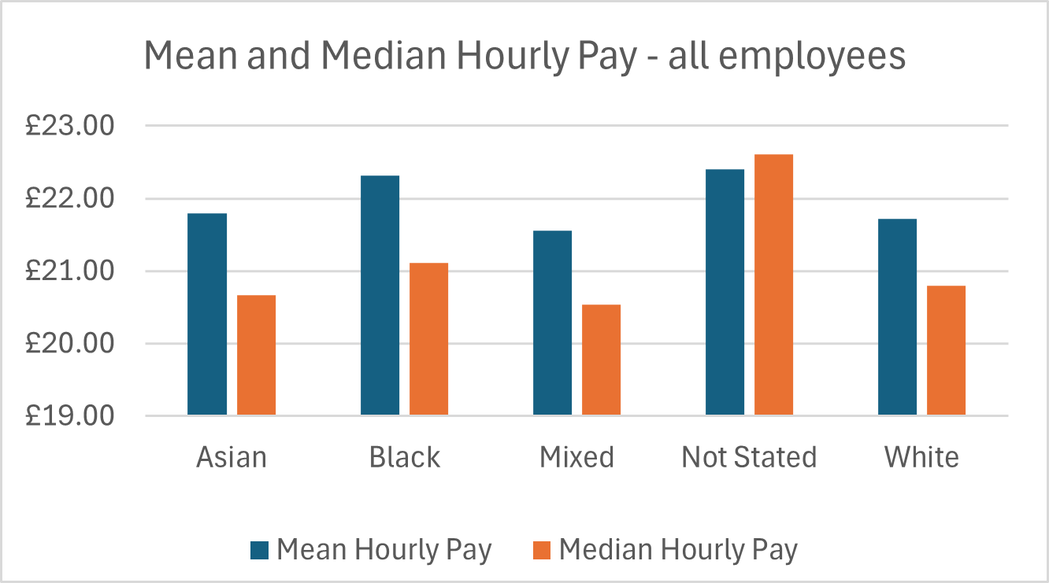
Graph 1 illustrates that the Black group has the highest mean and median hourly pay rate and the Mixed group the lowest. While our analysis shows that Black employees have the highest mean and median hourly pay, it is important to note that this group represents a small proportion of our overall workforce (4%) which means individual roles and pay levels within this group can have a disproportionate impact on the average figures.

Officer and Staff Mean and Median Ethnicity Pay Gap and Hourly Pay Rate
Table 6
 | Female officers |  | Male officers |  | Female staff |  | Male staff
 | Mean% | Median% | Mean% | Median% | Mean% | Median% | Mean% | Median %
Asian | 2.26% (£21.17) | -1.92% (£21.20) | -3.34% (£22.59) | -6.90% (£22.92) | % (£21.13) | -0.41% (£19.75) | -0.32% (£21.93) | 0.15% (£20.26)
Black | -6.46% (£23.06) | -15.19% (£23.96) | -5.44% (£23.05) | -10.59% (£23.71) | 0.28% (£21.18) | -5.74% (£20.08) | -4.76% (£22.90) | 2.46% (£19.79)
Mixed | 0.14% (£21.69) | -3.07% (£21.44) | 0.05% (£21.85) | 0.65% (£21.30) | -5.74% (£22.46) | -7.37% (£21.12) | 5.85% (£20.58) | 0.30% (£20.23)
White | 0% (£21.66) | 0% (£20.80) | 0% (£21.86) | 0% (£21.44) | 0% (£21.24) | 0% (£19.67) | 0% (£21.86) | 0% (£20.29)
*Figures in bold indicate highest hourly pay rate.

This year, male and female officers in the Black group had the highest mean and median hourly pay (compared to female officers in the Mixed group and male officers in the Black group last year). Consistent with last year, female staff in the Mixed group had the highest mean and median hourly pay. For male staff, those identifying as Black had the highest mean pay, while those in the staff White group had the highest median pay. This may be influenced by factors such as role type, grade distribution, and length of service.

Quartile Data

The pay data is split into four quartiles to determine where employees across the ethnic groups sit in the pay hierarchy.

Table 7 - All Employees Quartile Pay Rates
Ethnic Category | Upper  £24.20 – 86.79 |  | Upper Middle  £20.81-24.19 |  | Lower Middle  £17.92 – 20.80 |  | Lower  £10.95 – 17.91 |  | Total employed
 | No. | % of tot employed in ethnic group | No. | % of tot employed in ethnic group | No. | % of tot employed in ethnic group | No. | % of tot employed in ethnic group
Asian | 98 | 23.8 | 97 | 23.6 | 104 | 25.3 | 112 | 27.3 | 411
Black | 55 | 27.4 | 49 | 24.4 | 53 | 26.4 | 44 | 21.9 | 201
Mixed | 31 | 18.3 | 48 | 28.4 | 46 | 27.2 | 44 | 26.1 | 169
White | 921 | 23.46 | 970 | 24.71 | 928 | 23.64 | 1106 | 28.17 | 3925
Not stated | 49 | 30.82 | 50 | 31.45 | 24 | 15.09 | 36 | 22.64 | 159

Among all ethnic groups, employees from the Black ethnic group had the highest proportion represented in the upper quartile, while those from the Mixed group were most represented in the upper middle quartile. White employees had the highest proportion in the lower quartile, which is largely due to their overall higher numbers in the workforce (3,925) compared to other ethnic groups.
In terms of highest hourly pay rates, employees in the White ethnic group had the widest pay range in the upper quartile, with a maximum hourly rate of £86.79 (after salary sacrifice). This was followed by the Asian group at £74.09, the Mixed group at £43.35, and the Black group at £42.36. Consistent with last year’s findings, this reflects the continued trend of greater representation of White employees in senior roles and higher grades. Notably, the top hourly rate for the Asian group has increased significantly from £46.04 last year to £74.09, indicating a positive shift in representation at higher pay levels.

Bonus payments

Police Regulations allow for bonus payments to be made to officers. BTP has pay parity with Home Office forces and applies the same payments through policy. Chief Officers are not eligible to receive bonuses. Bonus payments are paid in the following circumstances:
- Make the Difference bonus - officers and staff are eligible for these awards which recognise outstanding work or contribution; payments range from £25 to £500.
- PDR rating 1 - staff are eligible for an award of £500 if they achieve a rating 1 in their annual performance development review.
- Temporary targeted payments –officers in hard to fill and demanding roles may receive a payment of up to £3,000. At present, BTP only utilises this allowance for Firearms Instructors, due to a national shortage of qualified individuals.
In 2025, 604 employees received a bonus, a decrease of 9.85% on last year (670).

All Employees Mean Ethnicity Bonus Gap
Table 8
Bonus payments – all employees
2025 |  |  |  |  |  | 2024
Ethnic Group | % awarded | Mean (£) | % Gap ** | Median | % Gap | % awarded | Mean (£) | % Gap ** | Median | % Gap
White (495) | 81.95% | 456.92 | 0% | 500.00 | 0% | 86.27% | 388.06 | 0% | 500.00 | 0%
Asian (45) | 7.45% | 311.11 | 31.91% | 225.00 | 55% | 6.27% | 458.33 | -18.11% | 500.00 | 0%
Black (20) | 3.31% | 241.25 | 47.20% | 213.00 | 57.4% | 2.98% | 295.00 | 23.98% | 250.00 | 50%
Mixed (26) | 4.3% | 321.15 | 29.71% | 300.00 | 40% | 2.24% | 346.67 | 10.67% | 500.00 | 0%
*N/S (18) | 2.98% | 545.83 | -19.46% | 450.00 | 10% | 2.24% | 408.33 | -5.22% | 500.00 | 0%
**against White group
Distribution of bonus payments to ethnic minority employees improved this year with an increased proportion of employees across each of the groups receiving a bonus. The highest mean bonus payment was paid to the White group; again, this year, the Black group had the lowest mean and median bonus payment indicating an under representation, in the award and value of bonus payments. When comparing bonus distribution by ethnic group against their proportion of the workforce: 3.31% of bonuses were awarded to employees from the Black ethnic group (compared to 4% of the workforce); 80.79% to the White group (aligned with 80.8% employed); 7.45% to the Asian group (compared to 8.4% employed); and 4.3% to the Mixed group (compared to 3.5% employed). This indicates that the White group was broadly aligned, the Mixed group received a higher proportion, while the Asian and Black groups were underrepresented in bonus awards.

Table 9 – Bonus Payments by Employee type and Ethnic group
Bonus payments – employee type
Ethnic group | Officers | % of employed | Staff | % of employed
White | 124 | 4.75% (2608) | 364 | 26.17% (1391)
Asian | 3 | 0.19% (157) | 42 | 16.22% (259)
Black | 3 | 3.79% (79) | 17 | 13.49% (126)
Mixed | 1 | 0.95% (105) | 25 | 36.23% (69)
Not Stated | 8 | 7.55% (106) | 10 | 18.87% (53)
This year saw a decline in the proportion of bonus payments awarded to officers, dropping to 23% compared to 40.9% in 2024. Of the 'Make the Difference' bonuses awarded to officers, 77% were received by those at Constable rank. All ethnic minority groups in the officer group experienced a decrease in bonus awards; notably, there was a reduction of over 50% in bonuses awarded to White officers.

What does this tell us about BTP’s ethnicity pay gap?

Overall, the mean pay gap has reduced across all ethnic minority groups this year. Again, this year, Black employees experienced the highest mean and median hourly pay rate whilst the Mixed group the lowest

White employees continue to have the widest pay range and highest hourly pay rates with 90% of senior ranks and 77% of senior grades occupied by White employees.
Encouragingly, this year has seen an increase in the top hourly pay rate for Asian employees, which has increased by 38% (from £46.04 to £74.09). This reflects greater representation in senior roles and higher pay bands. Whilst employees from the Black ethnic group have the highest proportion of their group represented in the upper quartile, the top hourly rate remains to be the lowest amongst all ethnic groups.

This year, the mean and median bonus payments for Asian, Black, and Mixed ethnic minority groups decreased. Notably, the mean bonus gap for Black employees widened to 47%, compared to 24% last year. In terms of maximum bonus payments, White employees received the highest ‘Make the Difference’ bonus of £725, while other ethnic groups received a maximum of £500; this was lower for staff in the Black group and officers in the Mixed group. Analysis of PDR bonus distribution shows that bonuses awarded to White and Mixed groups were higher than their share of the workforce, while Black and Asian groups received proportionally fewer bonuses.

The collective turnover rate for ethnic minority ethnic groups reduced this year to 8% (from 10.6%) which was lower than the White group (9.9%) and the overall turnover rate for BTP (9.5%). The reasons for leaving across each ethnic group were proportionate and comparable. When looking at new starters, fewer new starters identified as White (77% compared to 80% last year) and more starters identified as Asian, Black or Mixed, (19.3% compared to 18.6% last year), along with other factors, this may have contributed to the reduced gap this year.

Table 10A Table 10B
Officers employed by rank |  |  |  | Distribution across ethnic groups *
Rank | Number | % |  | Rank | White group | Mixed  group | Asian  group | Black group
Constable | 2303 | 75.4% |  | Constable | 85.06% | 3.47% | 5.43% | 2.86%
Sergeant | 495 | 16.2% |  | Sergeant | 85.86% | 3.63% | 4.04% | 1.82%
Inspector | 174 | 5.7% |  | Inspector | 86.21% | 2.30% | 5.75% | 1.15%
Chief Inspector | 52 | 1.7% |  | Chief Inspector | 88.46% | 1.92% | 3.85% | 1.92%
Superintendent | 20 | 0.7% |  | Superintendent | 85% | 10% | 0% | 5%
Chief Superintendent | 6 | 0.2% |  | Chief Superintendent | 100% | 0 | 0 | 0
Chief Officer | 5 | 0.2% |  | Chief Officer | 100% | 0 | 0 | 0

Table 11A Table 11B
Staff employed by grade |  |  | Distribution across ethnic groups
Grade | % staff employed |  | Grade group | White group | Mixed group | Asian group | Black group
A003 | 1.26% (24) |  | A003 | 58.33% (14) | 0 | 4.17% (1) | 29.17% (7)
A004 | 10.85% (206) |  | A004 | 68.45% (141) | 2.43% (5) | 16.02% (33) | 9.22% (19)
A005 | 16.33% (310) |  | A005 | 65.16% (202) | 5.16% (16) | 18.06% (56) | 7.74% (24)
A006 | 22.39% (425) |  | A006 | 76% (323) | 4% (17) | 12% (51) | 6.82% (29)
B001 | 14.70% (279) |  | B001 | 75.99% (212) | 2.51% (7) | 13.62% (38) | 5.02% (14)
B002 | 5.53% (105) |  | B002 | 75.24% (79) | 3.81% (4) | 15.24% (16) | 4.76% (5)
B003 | 8.01% (152) |  | B003 | 72.37% (110) | 3.95% (6) | 13.16% (20) | 7.89% (12)
B004 | 3.74% (71) |  | B004 | 83.10% (59) | 2.82% (2) | 7.04% (5) | 4.23% (3)
C001 | 3.16% (60) |  | C001 | 71.67% (43) | 5% (3) | 11.67% (7) | 10% (6)
C002 | 1.94% (37) |  | C002 | 72.98% (27) | 0 | 16.22% (6) | 5.41% (2)
C003 | 0.47% (9) |  | C003 | 77.78% (7) | 11.11% (1) | 11.11% (1) | 0
C004 | 0.68% (13) |  | C004 | 84.62% (11) | 0 | 7.69% (1) | 7.69% (1)
PCSO | 10.85% (206) |  | PCSO | 78.64% (162) | 3.88% (8) | 11.65% (24) | 1.94% (4)
Director | 0.05% (1) |  | Director | 100% (1) | 0 | 0 | 0
 | 1898 *
 |  |  |  | 1391 | 69 | 259 | 126
- Incl. Not Stated
Tables 10-11 above shows (A) the percentage breakdown of officers and staff across each rank/grade and (B) the percentage distribution of each ethnic group within different ranks/grades.

Intersectionality between ethnicity, gender and pay

We continue to review pay through an intersectional lens, considering both gender and ethnicity. However, because ethnic minority groups represent a relatively small proportion of employees, measures such as the mean pay gap can be distorted. It is therefore essential to examine intersectional factors individually to ensure that initiatives addressing gender and ethnicity pay gaps are aligned and effective.
Actions and Successes
We have continued to implement strategies to reduce the ethnicity pay gap and are committed to pursue this as part of our strategic priority to build a modern and inclusive force. New activity included:
- The Maturity Matrix has just gone live and BTP will track staff progression using a 1–5 rating scale (1 = early stage, 5 = leading practice). Results will be published externally, ensuring transparency and enabling both internal and external stakeholders to hold BTP accountable.
- The Youth Independent Advisory Group (YIAG) is active within BTP. Members will provide external scrutiny on stop and search and use of powers. A chair and co-chair have been elected, and members have been briefed on BTP activity. Over the coming months, an activity plan will be agreed to ensure YIAG voices influence key areas of BTP decision-making.
- Mainzworld has delivered community engagement projects in Manchester, Birmingham, Cardiff, Stratford, Bristol, and is now active in Glasgow. This work has increased Black representation in IAG/YIAG to around 20% and continues to grow. It has also strengthened partnerships with diverse youth organisations, where BTP provides workshops and policing insights. These initiatives support a joint approach to work experience, tracked through a new applicant system monitoring IAG, YIAG, and LEAG intake.
- The Youth Engagement Strategy gives PCSOs clear direction and more opportunities to engage with young people. PCSOs will lead youth engagement, supported by a new dashboard that uses crime and demographic data to target efforts.
- We are into our second year of the Black Talent Development Programme; a programme aimed at developing future black leaders for our organisation. We have seen a 72% increase in engagement compared to last year. Following an evaluation of the first year, where we assessed confidence, assertiveness and belief at the beginning of the year and then again at the end of the programme, confidence increased by 10.19%, assertiveness increased by 23.66% and belief that BTP is committed to improving representation increased by 15%.
- Our 2023-26 Policing Plans set out: ‘We will improve workforce representation to become a force which understands, and provides an effective service to, our communities’.
- Our recruitment advertisements and associated materials celebrate the diversity of our workforce. We have continued to train panel members in inclusive assessment techniques, as well as unconscious bias training; a mandatory requirement to support boards. We’ve also implemented a new, streamlined process to ensure candidates receive the reasonable adjustments they need to perform at their best during assessments. This includes a dedicated request form within our CRM, enabling candidates to outline the adjustments they feel would support them, while providing helpful suggestions they may wish to consider
- We are continually reviewing our officer promotion processes to make them fairer and more inclusive. In addition, we’ve established a Reasonable Adjustment Panel, working in partnership with our employee support associations, to assess requests and ensure we provide tailored, appropriate support wherever possible.
- PDR mid and end year scores continue to be monitored through a diversity lens to highlight any inequalities and identify appropriate corrective action Focus groups held to explore ways of embedding inclusion and diversity within PDR objectives.
- To help everyone understand how they can contribute to the PRAP, we developed role-based personas. These provide practical examples of actions individuals can take, whether as team members, line managers, or senior leaders, to embed PRAP principles into daily work and performance objectives.
- All people policies are subject to an equality impact assessment to ensure that fairness and inclusion is at the heart of what we do.

Next Steps

- Collaborating with the Citizens in Policing team to confirm their capacity to take ownership of the Youth Engagement Strategy. Findings will be reported to the ACC’s Neighbourhood Policing Board by the end of 2025, ensuring the strategy is embedded within a permanent team and aligned with broader organisational priorities.
- Developed a Black History e-learning training package exploring the historical context of policing Black communities, reasons for lower trust, its impact on policing, and how learners can help improve trust and confidence. It includes reflective conversations to document change. The content addresses both internal and external perspectives
- Committed to 4 hours training per employee on Equality, diversity and inclusion.
- Assess the impact of pay gaps on employees from mixed ethnic backgrounds to identify disparities and inform targeted actions for equity
- Develop 15 Indicators of Racism to measure progress on anti-racism efforts, covering areas such as representation across ranks and roles, equitable distribution of bonus payments, and alignment of PDR objectives
- Establish a Female Representation Working Group, led by a Chief Inspector to consolidate initiatives aimed at increasing female officer representation. The group will monitor progress, align efforts across teams, and ensure collective accountability for achieving this objective. accountability for achieving this objective. this objective

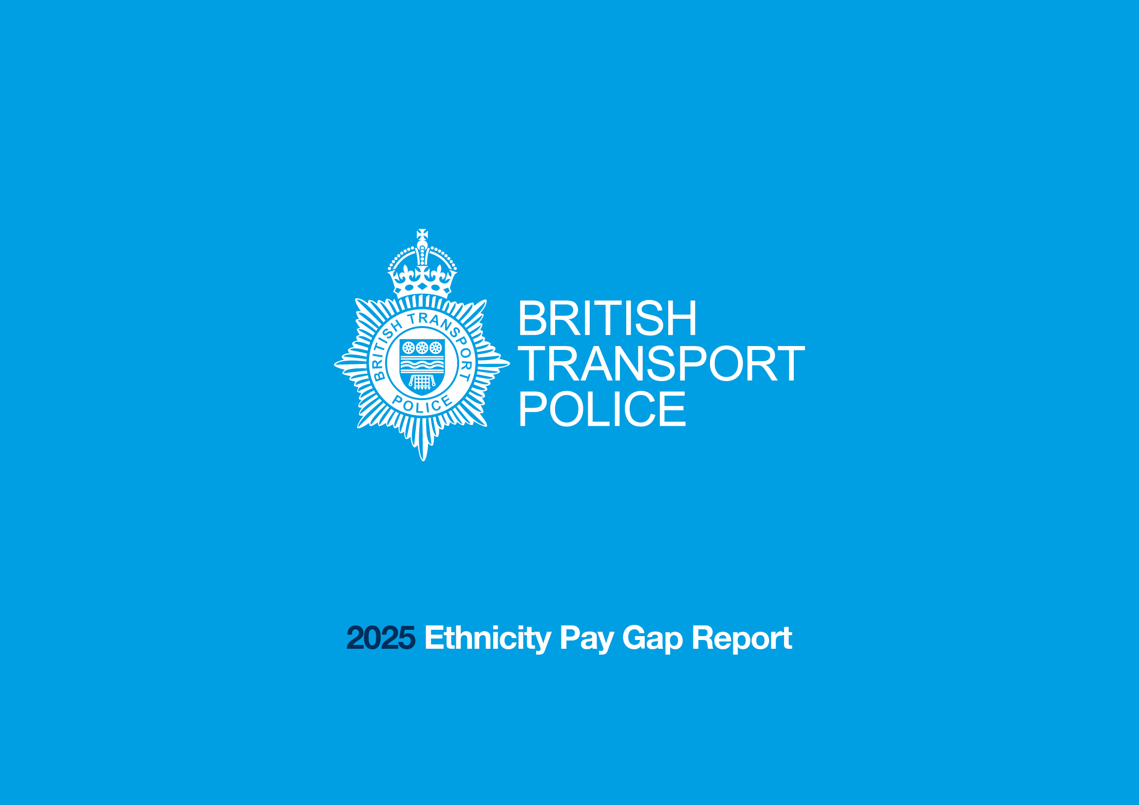

Police workforce, England and Wales: 31 March 2025 (second edition) - GOV.UK
Statistical bulletin - Civil Service Statistics: 2025 - GOV.UK

